**EX.NO:5 DATE: 13.02.2025**

**EDGE DETECTION, NOISE ADDITION AND REMOVAL**

**Aim:**

To apply edge detection, noise addition, and noise removal techniques to analyze image processing methods.

**Algorithm:**

1. Convert the image to grayscale.  
2. Apply different edge detection techniques such as Sobel, Prewitt, Roberts, and Laplacian of Gaussian.  
3. Implement noise addition methods including Gaussian, Salt & Pepper, and Impulse noise.  
4. Use various noise removal techniques such as Gaussian Blur, Median Filtering, and Bilateral Filtering.  
5. Display the processed images and analyze their histograms.

Code

import cv2  
import numpy as np  
import matplotlib.pyplot as plt  
import seaborn as sns

image = cv2.imread("lena.jpeg", 0)  
image2 = cv2.imread("edge.jpg", 0)

# Edge Detection

def edge_detection(image):  
   
 rows, cols = image.shape  
   
 sobel_x = np.array([[-1, 0, 1], [-2, 0, 2], [-1, 0, 1]])  
 sobel_y = np.array([[-1, -2, -1], [0, 0, 0], [1, 2, 1]])  
   
 prewitt_x = np.array([[-1, 0, 1], [-1, 0, 1], [-1, 0, 1]])  
 prewitt_y = np.array([[-1, -1, -1], [0, 0, 0], [1, 1, 1]])  
   
 robert_x = np.array([[1, 0], [0, -1]])  
 robert_y = np.array([[0, 1], [-1, 0]])  
   
 laplacian = np.array([[0, 1, 0], [1, -4, 1], [0, 1, 0]])  
   
 methods = {  
 'Sobel': (sobel_x, sobel_y),  
 'Prewitt': (prewitt_x, prewitt_y),  
 'Robert': (robert_x, robert_y),  
 'LoG': (laplacian, None)  
 }  
   
 results = {}  
   
 for method, (kernel_x, kernel_y) in methods.items():  
 gradient_x = np.zeros_like(image, dtype=np.float32)  
 gradient_y = np.zeros_like(image, dtype=np.float32) if kernel_y is not None else None  
   
 for i in range(1, rows-1):  
 for j in range(1, cols-1):  
 if method in ['Sobel', 'Prewitt', 'LoG']:  
 gradient_x[i, j] = np.sum(kernel_x * image[i-1:i+2, j-1:j+2])  
 if kernel_y is not None:  
 gradient_y[i, j] = np.sum(kernel_y * image[i-1:i+2, j-1:j+2])  
 elif method == 'Robert':  
 gradient_x[i, j] = np.sum(kernel_x * image[i:i+2, j:j+2])  
 gradient_y[i, j] = np.sum(kernel_y * image[i:i+2, j:j+2])  
   
 if kernel_y is not None:  
 gradient_magnitude = np.sqrt(gradient_x**2 + gradient_y**2)  
 else:  
 gradient_magnitude = np.abs(gradient_x)  
   
 gradient_magnitude = (gradient_magnitude - gradient_magnitude.min()) / (gradient_magnitude.max() - gradient_magnitude.min()) * 255  
 results[method] = gradient_magnitude.astype(np.uint8)  
   
 weak, strong = 50, 150  
 canny_edges = np.zeros_like(image)  
 strong_edges = results['Sobel'] > strong  
 weak_edges = (results['Sobel'] >= weak) & (results['Sobel'] <= strong)  
 canny_edges[strong_edges] = 255  
 canny_edges[weak_edges] = 100  
 results['Canny'] = canny_edges  
  
 plt.figure(figsize=(18, 6))  
 for i, (method, result) in enumerate(results.items(), 1):  
 plt.subplot(2, 5, i)  
 plt.imshow(result, cmap='gray')  
 plt.title(f'{method} Edge Detection')  
 plt.axis('off')  
 plt.subplot(2,5,i+5)  
 plt.imshow(result-255, cmap='gray')  
 plt.title(f' {method} Edge Detection Negative')  
 plt.axis('off')  
   
 plt.show()

edge_detection(image)  
edge_detection(image2)

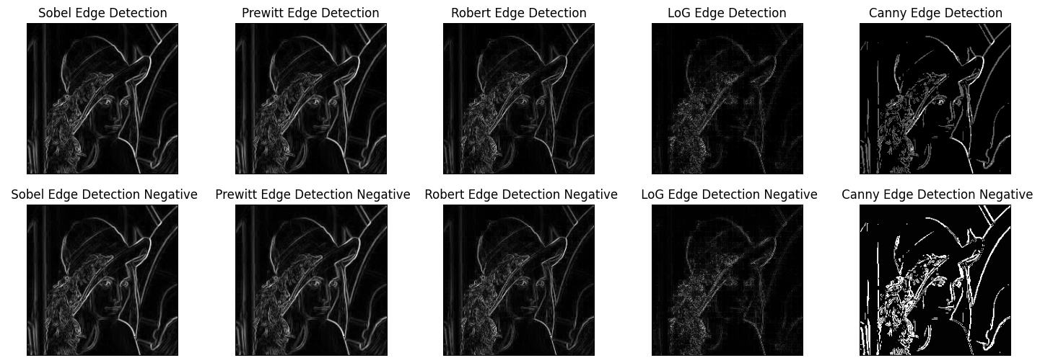

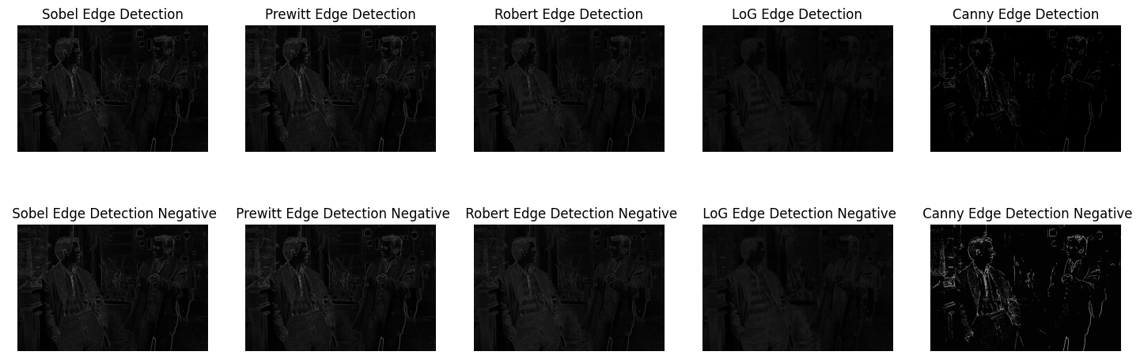

# Noise Addition

import numpy as np  
import matplotlib.pyplot as plt  
import cv2  
  
def noise_addition(image, nv=25, sp_ratio=0.02, quant_levels=10, impulse_ratio=0.02):  
 if len(image.shape) == 3:  
 gray_image = cv2.cvtColor(image, cv2.COLOR_BGR2GRAY)  
 else:  
 gray_image = image  
   
 images = {"Original Color": image, "Original Gray": gray_image}  
 noises = {}  
   
 gaussian_noise = np.random.normal(0, nv, image.shape)  
 noises["Gaussian Color"] = np.clip(image + gaussian_noise, 0, 255).astype(np.uint8)  
 noises["Gaussian Gray"] = np.clip(gray_image + gaussian_noise[..., 0], 0, 255).astype(np.uint8)  
   
 salt_pepper = np.random.rand(*gray_image.shape)  
 sp_color = np.copy(image)  
 sp_gray = np.copy(gray_image)  
 sp_color[salt_pepper < sp_ratio/2] = 0  
 sp_color[salt_pepper > 1 - sp_ratio/2] = 255  
 sp_gray[salt_pepper < sp_ratio/2] = 0  
 sp_gray[salt_pepper > 1 - sp_ratio/2] = 255  
 noises["Salt & Pepper Color"] = sp_color  
 noises["Salt & Pepper Gray"] = sp_gray  
   
 noises["Quantization Color"] = (image // (256 // quant_levels)) * (256 // quant_levels)  
 noises["Quantization Gray"] = (gray_image // (256 // quant_levels)) * (256 // quant_levels)  
   
 impulse_noise = np.random.rand(*gray_image.shape)  
 impulse_color = np.copy(image)  
 impulse_gray = np.copy(gray_image)  
 impulse_color[impulse_noise < impulse_ratio/2] = 0  
 impulse_color[impulse_noise > 1 - impulse_ratio/2] = 255  
 impulse_gray[impulse_noise < impulse_ratio/2] = 0  
 impulse_gray[impulse_noise > 1 - impulse_ratio/2] = 255  
 noises["Impulse Color"] = impulse_color  
 noises["Impulse Gray"] = impulse_gray  
   
 images.update(noises)  
   
 fig, axs = plt.subplots(len(images), 2, figsize=(12, len(images) * 3))  
   
 for i, (noise_type, img) in enumerate(images.items()):  
 cmap = None if len(img.shape) == 3 else 'gray'  
 axs[i, 0].imshow(img, cmap=cmap)  
 axs[i, 0].set_title(f"{noise_type} Image")  
 axs[i, 0].axis("off")  
 axs[i, 1].hist(img.ravel(), bins=256, range=[0, 256], color='gray', alpha=0.7)  
 axs[i, 1].set_title(f"Histogram of {noise_type} Image")  
   
 plt.tight_layout()  
 plt.show()  
  
 return noises["Gaussian Color"]

image = cv2.imread('lena.jpeg', 1)  
image = cv2.cvtColor(image,cv2.COLOR_BGR2RGB)  
noisy_image = noise_addition(image,70)

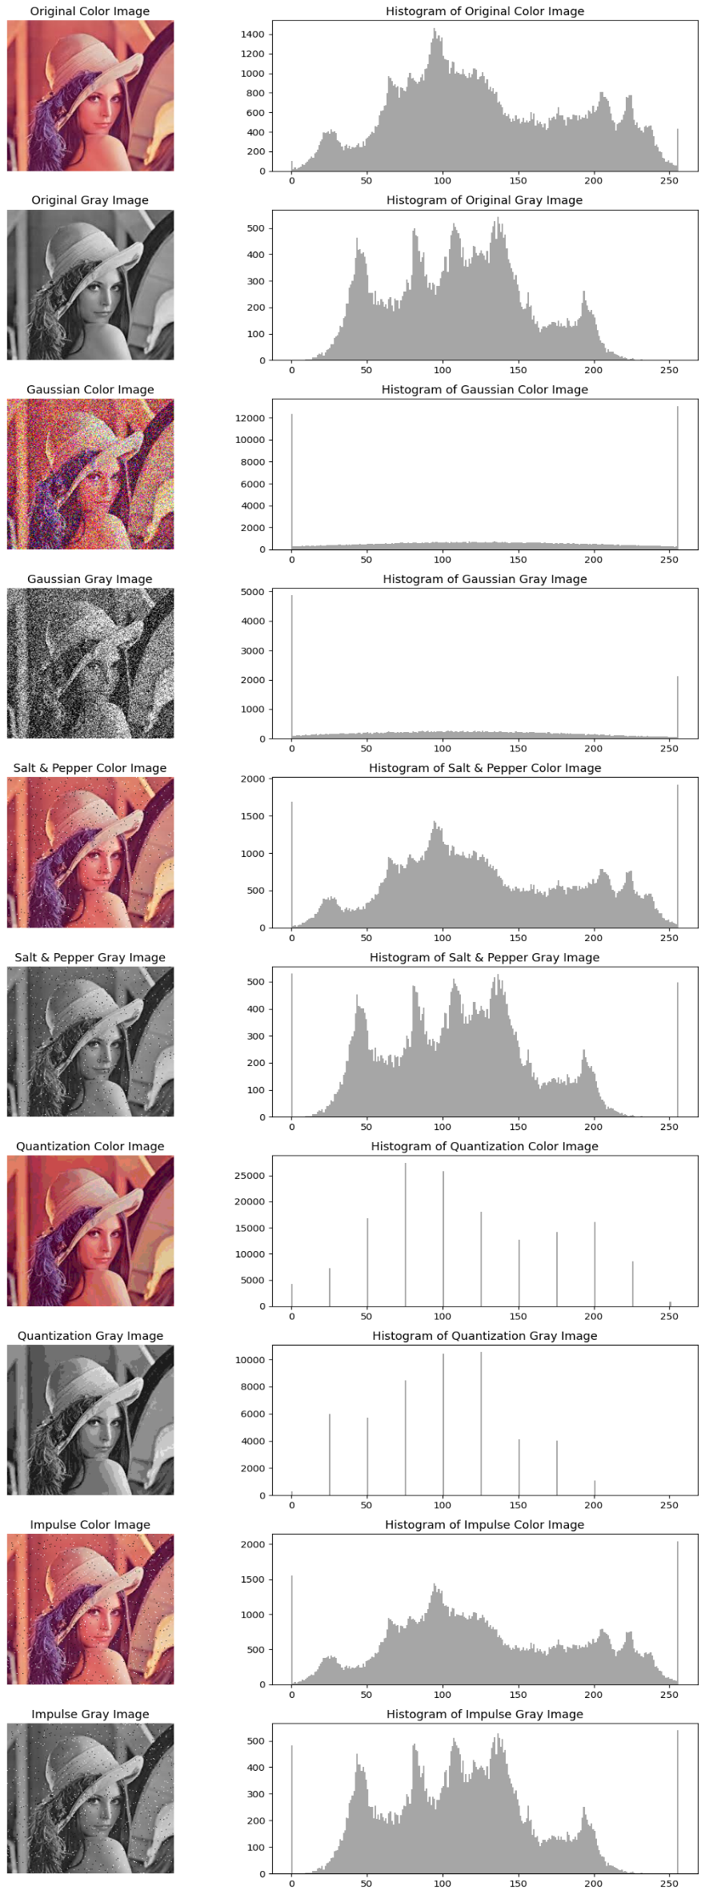

image2 = cv2.imread("edge.jpg", 1)  
image2 = cv2.cvtColor(image2, cv2.COLOR_BGR2RGB)  
nimage = noise_addition(image2, nv=100, sp_ratio=0.3, quant_levels=3, impulse_ratio=0.3)

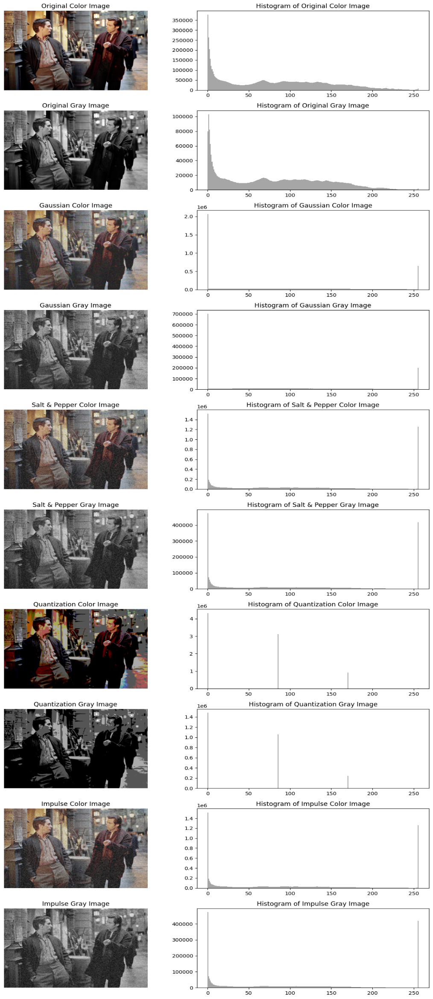

# Noise Removal

def custom_gaussian_blur(image, kernel_size=5, sigma=1.0):  
 kernel = cv2.getGaussianKernel(kernel_size, sigma)  
 kernel = np.outer(kernel, kernel)  
 return cv2.filter2D(image, -1, kernel)  
  
def custom_median_blur(image, kernel_size=5):  
 padded_image = np.pad(image, kernel_size // 2, mode='edge')  
 output = np.zeros_like(image)  
 for i in range(image.shape[0]):  
 for j in range(image.shape[1]):  
 output[i, j] = np.median(padded_image[i:i+kernel_size, j:j+kernel_size])  
 return output  
  
def custom_bilateral_filter(image, d=9, sigma_color=75, sigma_space=75):  
 filtered_image = np.copy(image)  
 for i in range(image.shape[0]):  
 for j in range(image.shape[1]):  
 neighborhood = image[max(0, i-d//2):min(image.shape[0], i+d//2+1),  
 max(0, j-d//2):min(image.shape[1], j+d//2+1)]  
 color_weights = np.exp(-((neighborhood - image[i, j])**2) / (2 * sigma_color**2))  
 space_weights = np.exp(-((np.arange(neighborhood.shape[0])[:, None] - d//2)**2 +   
 (np.arange(neighborhood.shape[1])[None, :] - d//2)**2) / (2 * sigma_space**2))  
 weights = color_weights * space_weights[..., np.newaxis]  
 weights /= np.sum(weights)  
 filtered_image[i, j] = np.sum(neighborhood * weights)  
 return filtered_image  
  
def remove_all_noises(image):  
   
 denoised_methods = {  
 "Custom Gaussian Blur": custom_gaussian_blur(image),  
 "Custom Median Blur": custom_median_blur(image),  
 "Custom Bilateral Filter": custom_bilateral_filter(image)  
 }  
   
 fig, axs = plt.subplots(len(denoised_methods) + 1, 2, figsize=(12, (len(denoised_methods) + 1) * 3))  
   
 axs[0, 0].imshow(image, cmap='gray' if len(image.shape) == 2 else None)  
 axs[0, 0].set_title("Original Noisy Image")  
 axs[0, 0].axis("off")  
 axs[0, 1].hist(image.ravel(), bins=256, range=[0, 256], color='gray', alpha=0.7)  
 axs[0, 1].set_title("Histogram of Original Noisy Image")  
   
 for i, (method, denoised) in enumerate(denoised_methods.items(), 1):  
 cmap = 'gray' if len(denoised.shape) == 2 else None  
 axs[i, 0].imshow(denoised, cmap=cmap)  
 axs[i, 0].set_title(f"{method}")  
 axs[i, 0].axis("off")  
 axs[i, 1].hist(denoised.ravel(), bins=256, range=[0, 256], color='gray', alpha=0.7)  
 axs[i, 1].set_title(f"Histogram of {method}")  
   
 plt.tight_layout()  
 plt.show()

remove_all_noises(noisy_image)

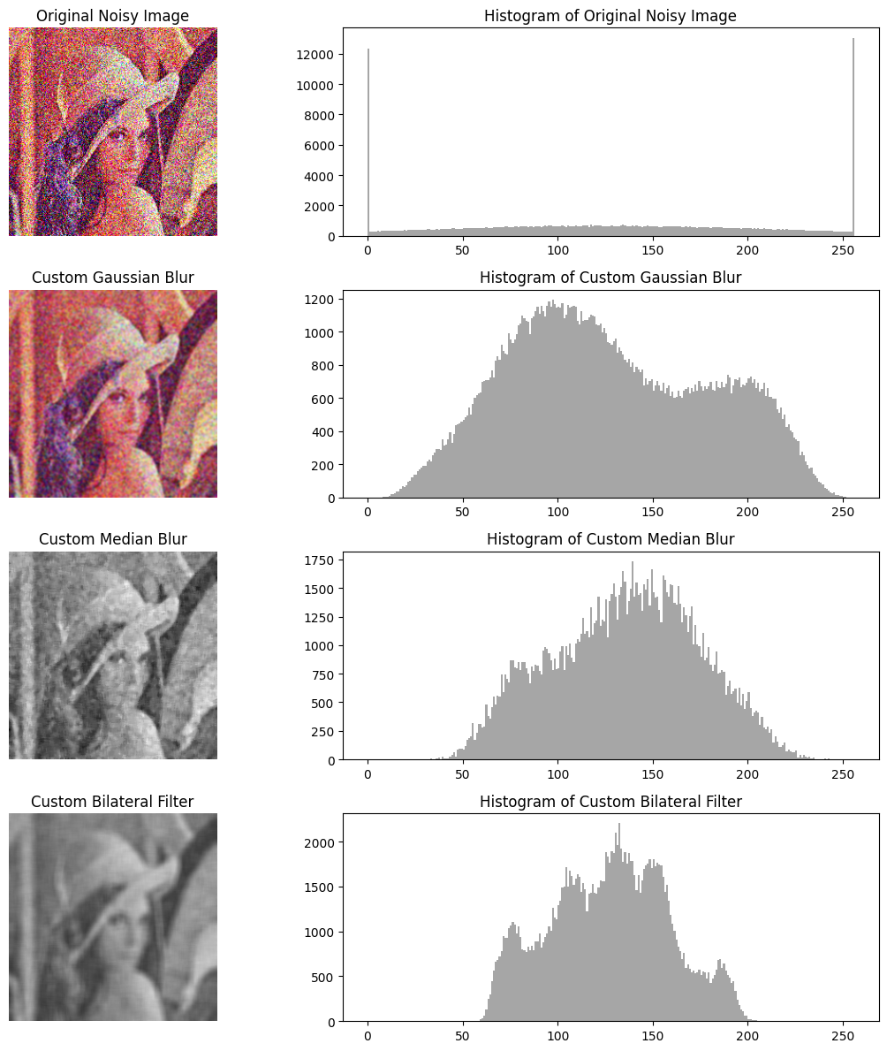

remove_all_noises(nimage)

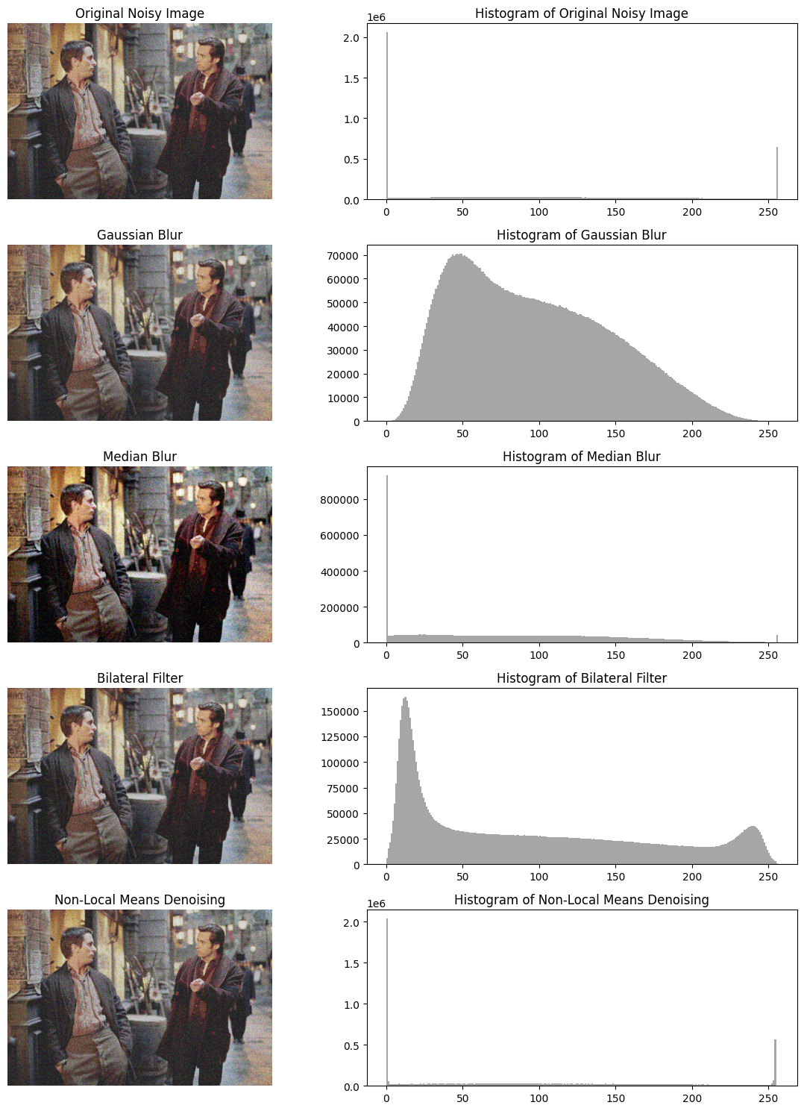

**Inference**

- Edge detection highlights object boundaries using different gradient-based methods.  
- Adding noise affects image quality, making analysis difficult.  
- Noise removal techniques help restore image clarity by reducing unwanted distortions.

**Result:**The applied edge detection, noise addition, and removal techniques successfully processed images, demonstrating the impact of various filters and noise types on image quality.